SMS/Text Messaging
If your number is eligible, we can add SMS/MMS texting ability to your account at no additional charge. Adding this capability can take anywhere from seconds to several days. To check eligibility and add this capability, email support@ring-u.com or call 423-567-4888.
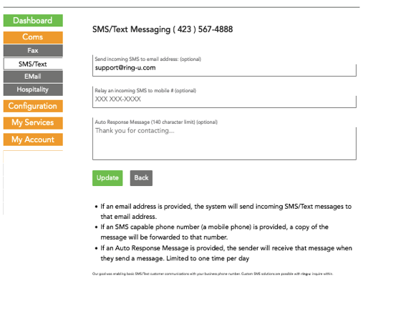
Once enabled, you will have a web interface (Coms>SMS/Text) to send and receive SMS/Text messages, and a configuration screen. You have 3 powerful options you can use.
- Forward incoming SMS/Email messages to an e-mail address.
- Relay the incoming message to a mobile phone. You can reply via the mobile phone directly, or the Hello Hub web interface.
- Auto-Response will reply 1 time per 24 hours to a sender with information about your business or useful information. It can update customers about your hours, policies, or anything that fits in 140 characters.

TextBack
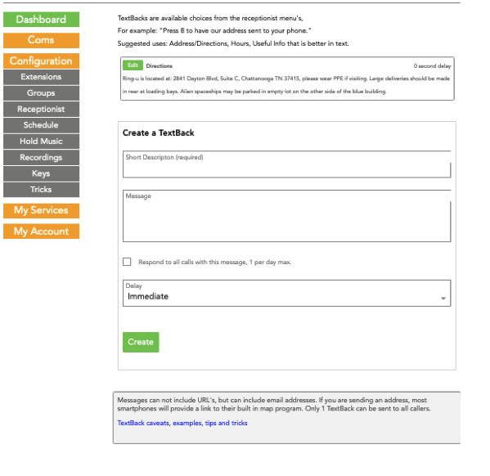
SMS enabled numbers and systems also enable TextBack features. Create messages that can be sent on request to your callers as a choice from the interactive menus. For example: “Press 6 for hours and address to be sent to your phone.” Of course, this only works if they are calling from an SMS/Text capable phone (all mobile phones, and some VoIP systems).
- You can send up to two 140 character messages.
- You can NOT send full URL's.
- You CAN send domain names and email addresses.
- People can “Opt-Out”.
There is also a special AllCall flag you can set on one TextBack. Every caller will be sent this message, but only one time per 24 hours. We recommend setting the delay to more than 5 seconds. It can be disorienting or frustrating to be trying to call someone and receive an SMS/Text at the same time. It works well as a follow up message. “Thank you for calling...”

Example
This example of a fictional medical office is a good example of an option for directions, and a message for everyone that calls.

AllCall TextBack Number Selection
By default, any call to any number on your system will trigger an AllCall TextBack. If you have more than one phone number, you can select to not have calls to that number trigger an AllCall TextBack under the Numbers menu. This is suggested for dedicated fax numbers and numbers for specific purposes besides customer contact.

SMS Opt-Out Keywords and Stop Words
Ring-u automatically processes incoming messages and recognizes English-language stop words. Stop words are specific words such as STOP or UNSUBSCRIBE that signal that a person no longer wishes to receive messages from you.
When your ring-u phone system identifies a stop word, the person's phone number is added to the opt-out list and you will no longer be able to send messages to that number. Any further messages from your account that are sent to a number on the opt-out list will not be processed.
Please note that stop words are only recognized if they are the only words in the message. For example, “stop all” is recognized but “please stop all messages” would not be recognized.
Your ring-u phone system recognizes the following English-language stop words:
- stop
- stopall
- stop all
- unsubscribe
- cancel
- end
- quit
Your ring-u phone system will remove a number from the opt-out list if any of the following words are detected:
- start
- unstop

