PA Ring Tone
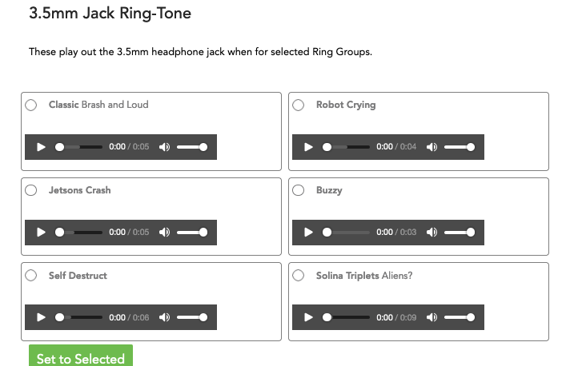
If you are using a PA system via the 3.5 mm jack (Hello Hub V1) or USB Dongle (Hello Hub V2), select a ring tone here.
These ring tones provide a range of pitch and sounds with the intentions of being heard over office, shop and equipment noise.

