Options
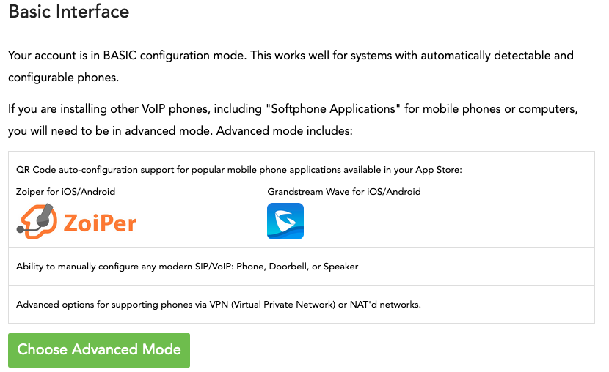
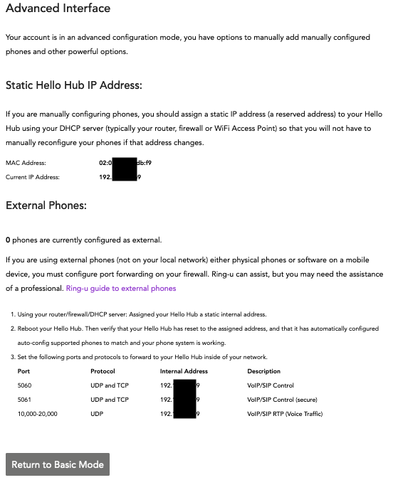
Basic Interface
By default, all ring-u accounts are set to Basic Interface mode.
This works well for systems with automatically detectable and configurable phones.
Advanced Interface
If you will be installing other VoIP phones requiring manual configuration, including “Softphone Applications” such as Zoiper or Grandstream Wave (or Lite) for mobile phones or computers, you will need to be in advanced mode.
Advanced is also required for doorbell or public address integration, and systems which will require supporting phones via VPN or NAT'd networks.

