Music / Message on Hold by 3rd Party
This feature will be public on April 2nd 2024 - Currently in development/testing.

Overview
Ring-U customers with outside / 3rd party providers of hold music / messaging can update their systems hold music and various audio files three ways:
- The ring-u customer or their IT Professional uploads via the web interface under Configuration->Music On Hold.
- The provider of audio files provides a unique URL that the system checks for updates daily. This URL field is also available under Configuration->Music On Hold
- The provider of audio files sends the file via email.
Caveats:
- The raw file must be less that 10GB (10 GigaBytes)
- .MP3, .WAV and OGG file are supported. Formats with DRM (like many Apple formats) are not.
- The customer and provider assumes all liability for licensing and permission for the audio content.

By URL
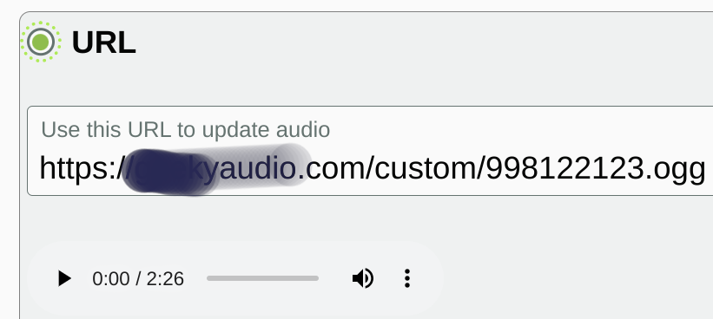
Available under Configuration->Music On hold
The URL is provided by the audio file producer and added/updated by the customer. It does not work with streams.
The URL is tested for changes every morning, or when this screen is updated, and if changed, downloaded and system updated. If the URL is invalid or the file is invalid, it does NOT change the system.

By Email
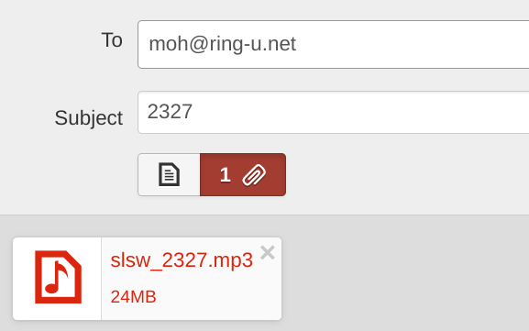
To ensure authorized parties submit the audio file for the system, the first step it to create an extension (a voicemail only extension is great for this) and put the email address of the sender on that extension in Email field. This authorizes that email address to submit audio files for that account. The sender will receive a reply with a confirmation (or errors). The subject line of the email must have the account number in it, as show. The phone system will be using this file approximately 10 minutes after sent this way. It can be tested on site by dialing 708.
This method works well with freelance audio recording professionals and bespoke professionals like:InphoStudio that provide periodic updates

