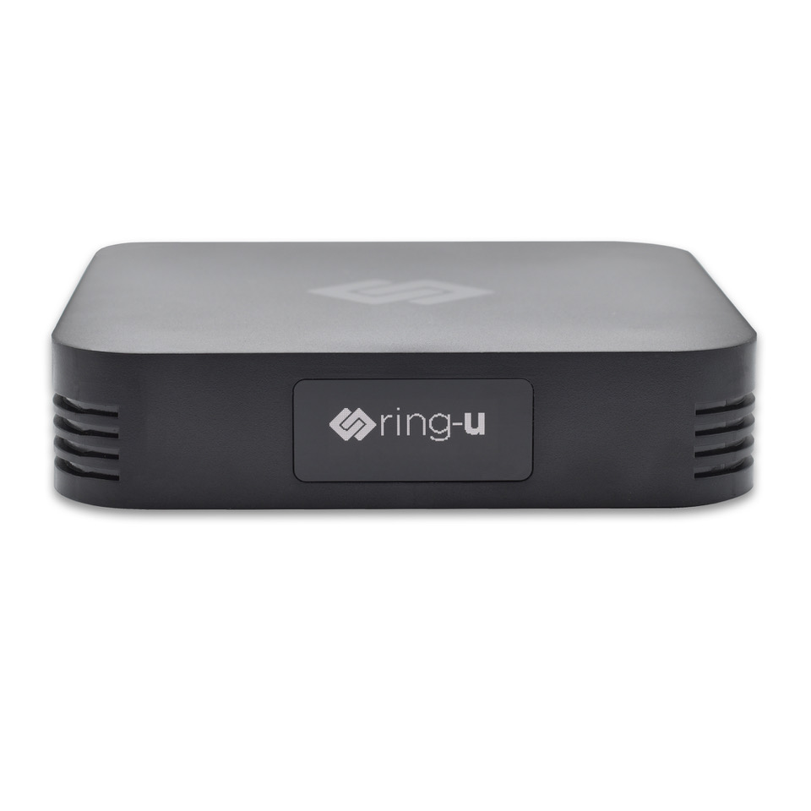
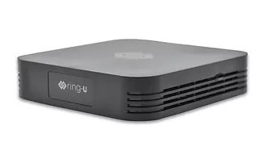

Hello Hub V2
At the center of every ring-u phone system is the Hello Hub.
This little box connects your phones, manages your calls, controls your phone menus, handles voicemail, and so much more.
And it does all of this while being smaller than most of the phones it connects.
The V2 builds on all the successes of our V1 Hub, but introduces an OLED display in place of its predecessor's 3 lights.
The OLED displays a number of helpful messages, seen in the image below.


