Grandstream HT801/HT802 Tricks

Auto-Dial When a Handset Is Picked Up (Elevator/Lobby Phone)
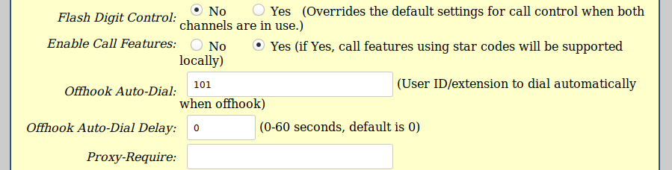
To use the HT801 or HT802 as an Elevator or Lobby phone, manually configure the settings as below from the web interface for an HT801 or HT802.
Using a web browser, click on the IP address in your customer portal for that extension & login as either admin/admin or admin/passwordyouset. Under FX Port (1 or 2), scroll down to Off-Hook Auto Dial & input in the number you want it to dial, for example the extension number of the receptionist's phone.
If this will be for emergency use, you might want to use:
- 500 for all phones,
- the number of a special call group,
- a mobile phone number, or
- 911.
Warning: use 911 only if that's the only option or is required for elevator use. They do not like non-emergency calls and you may incur charges or property damage for them. ring-u is not responsible for any inappropriate 911 use or damage resulting from it, financial, real property, or otherwise.

Upgrading an HT802
We've seen a rash of new HT802's with really old firmware on them. They need to be manually updated via a web browser.
We've been having good results with Version 1.0.10.6 and keep a copy handy.
To check your firmware version - Pick up the phone connected to the HT802 and dial the * key on your phone 3 times. Have a pen and paper ready. When you hear the message to enter a menu option, please enter 0 2 on your phone. You will now hear a message giving you the IP address of your HT802, such as: “192.168.2.x.” Write this down.
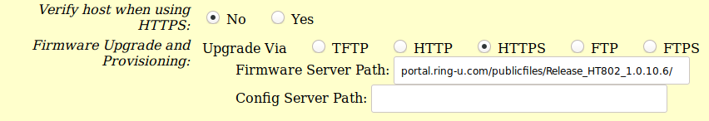
1. Login to the web interface of the HT802, using a web browser and the IP address you just wrote down, (such as http://192.168.1.132 and use the default login/password of admin and admin. 2. Under system update, use https://portal.ring-u.com/publicfiles/Release_HT802_1.0.10.6/ for the FIRMWARE update path. By picking/clicking HTTPS and then using portal.ring-u.com/publicfiles/Release_HT802_1.0.10.6/ as the path.
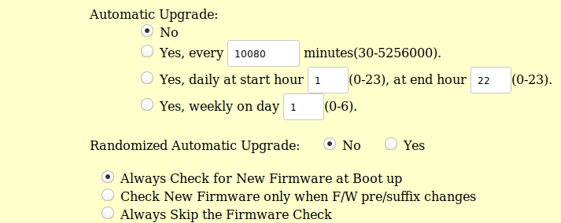
3. Make sure: Check for new firmware on boot is chosen. 4. Click Update. Apply, then Reboot
5. Walk away for 10-15 minutes.
6. Try to login again and check the version number.

