Headsets - Wired and Bluetooth

Wired
The GRP2614,GRP2615, & GRP2616 phones support normal RJ11 headset and Plantronics EHS headsets. To use a Plantronics EHS headset:
- Go to the Phone Menu > Preferences > Audio Control: Headset Type.
- Select Plantronics EHS then reboot the phone.
- Connect Plantronics EHS Headset into the RJ11 headset port on the back of the phone.
- To use headset mode, press headset button 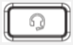. A headset icon will show on the LCD.
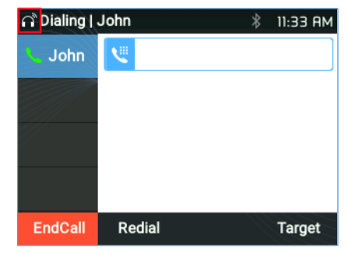Headset Mode Enabled

Bluetooth
GRP2614,GRP2615, & GRP2616 phones are also capable to connect to Bluetooth devices. supporting Bluetooth version 5. Users could connect to cellphones (supporting Bluetooth) via hands free mode or use Bluetooth headset for making calls. To connect to a Bluetooth device, turn on the Bluetooth radio first. The first time when using a new Bluetooth device with the GRP2614/GRP2615 & GRP2616, “pair” the device with the phone so that both devices know how to connect securely to each other. After that, users could simply connect to a paired device. Bluetooth related settings are under Phone’s LCD Menu → System → Bluetooth.

