WiFi Tuning and Softphones
Baed on Articles by TP-Link, Ubiquiti and Others - merged by a real human with 20+ real world years of experience.

How to Improve Your Wi-Fi Signal and Wireless Range
Weak Wi-Fi signal, slow speeds, or limited range are common problems with a few reliable solutions. This guide covers three categories of fixes: choosing the right location for your router, adjusting its configuration settings, and expanding your Wi-Fi coverage when needed.
- Choosing the best location
- Optimizing the configuration of the device
- Expanding your Wi-Fi coverage

Key Takeaways
- The 5 GHz Wi-Fi band offers faster speeds but shorter range, and is more sensitive to physical obstacles than the 2.4 GHz band.
- Common causes of weak Wi-Fi include physical barriers like walls and ceilings, interference from devices like microwave ovens and cordless phones, channel conflicts with nearby routers, and poor router placement.
- Too many access points close together can cause devices to hop between them, making connections unstable. Some devices will try to stay connected to multiples, which can trigger software like Acrobits softphones to re-register on many access points. This confuses where that two way handshake and audio stream should transit. This might be a setting in the devices wifi settings that you can select. For example: Zebra and other commercial devices (non consumer oriented) have special WiFi Managers with complex options for commercial WiFi network implementation. See example: https://techdocs.zebra.com/emdk-for-android/6-8/mx/wifi/
  - Positioning antennas vertically (for the same floor coverage) or at 30 degrees (for multi-story building coverage) can improve signal spread.
- Switching your 2.4 GHz router channel to 1, 6, or 11, and 5GHz channel to 36-48 can reduce interference in environments with many overlapping Wi-Fi networks.
- If your router’s current Wi-Fi signal doesn’t reach every corner of your location, you can add compatible devices to eliminate dead zones.

Symptoms
Weak Wi-Fi signal, slow Wi-Fi speed, intermittent VoIP problems or limited range. Unlike most internet usage, low latency 2 way audio requires a connection to ONE access point at a time.

Cause
The factors most frequently affecting the Wi-Fi signal:
- Intrinsic Factors
- Transmission Distance.
- Badly or overly configured WiFi
For wireless devices operating on the 5 GHz band, the signal is more sensitive to obstacles. Though the 5 GHz band offers clearer channels than the 2.4 GHz band, the Wi-Fi signal is reduced significantly and travels a shorter range due to the higher frequency.

Antenna
Omni-directional antennas and directional antennas
Omni-directional antennas are found in home products like wireless routers and wireless ADSL2+ Modem Routers. They radiate horizontally in all directions, but produce a weaker signal above and below the antenna, as the picture shows.
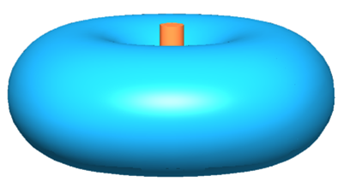
Directional antennas radiate strongly in a particular direction and are typically used for high-power outdoor products. As the gain of a directional antenna increases, so does the coverage distance, but the effective coverage angle decreases.
In general, a higher antenna gain value produces a more directional signal, increasing range in one direction while narrowing the overall coverage angle.
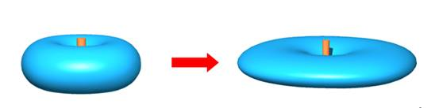
Directional antennas concentrate signal energy in a specific direction, with little energy transmitted behind the antenna. Refer to the picture below.
This narrowing effect becomes more pronounced with High-Gain antennas. Make sure the antenna is aimed precisely in the direction you need coverage, as misalignment can cause significant signal loss.
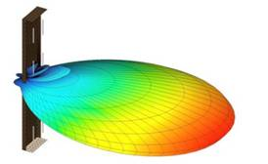
Wireless Communication Performance.
Higher transmission rates, is essentially better performance. Signal To Noise Ration is important. Often people think more power is better, when it is often noisier. Think distorted heavy metal guitar of Wifi. Power bosters have to be installed carefully. Mesh extenders, power line relays, and repeaters are NOT suitable for VoIP communications. They increase latency and jitter. The proper coverage of wired access points with good antennas suitable for the location is the best answer.


