System & Hardware Variants
Hello Hub V2 | 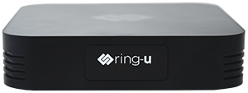 | 2022 update of original Hello Hub.
Cloud Connector | 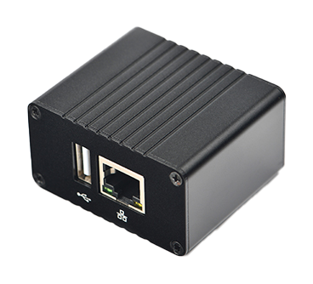 | Best for remote workers. Works with Hello Hub or Hello Hub Cloud.
Hello Hub V1 | 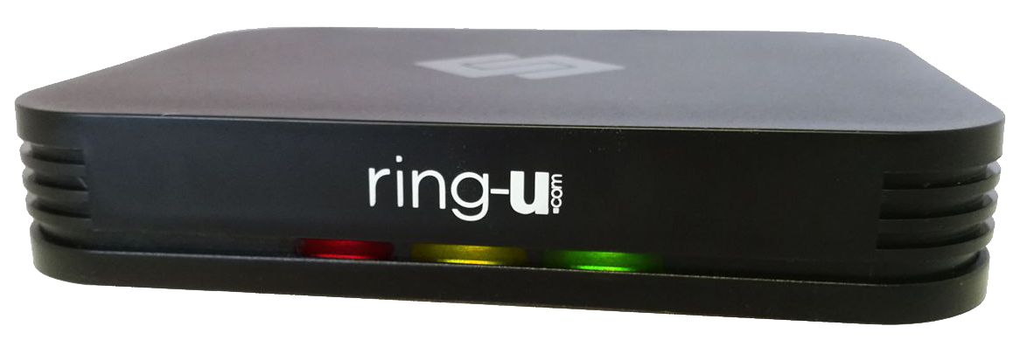 | Original edition.
Hello Hub Micro Server | 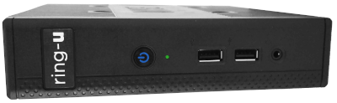 | Heavy duty fanless AMD64 for harsher environments and higher capacity
Hello Hub Cloud |  | Best for wide area, remote workers. Works with or without our *Cloud Connector*

