Reliability and Stability
A single page with everything we know about the reliability and stability of Hello Hubs and associated phone service.Ring-u's very first customer (#99) has been online since June 2017. We have thousands of systems out in the field that never have a problem. We've also had a few nightmares and learned a lot.
Things we have learned, in order of applicability:

Reserve an IP Address

Our #1 recommendation for system reliability
When a Hello Hub boots, it checks to see if it has the same network address it had before, and if not, scans for phones on your network to tell them it's new address. Your system is much more stable if the Hello Hub always gets the same address from your router/firewall/DHCP server. Most modern small network routers make it easy to find the list of things on your network and reserve an address for the Hello Hub. It will usually show up as “ring-u” in the list of DHCP leases in your router with a one button/click “reserve/assign an address” button. This is often the biggest improvement that can be made in the stability of your phone system.

No Port Forwarding
Your Hello Hub does not need your firewall/router to forward traffic to it for normal usage. If you do not need external phones, do not forward ports. If you have ports forwarded, your Hello Hub will be constantly probed by the internet by the curious and nefarious. It has an adaptive firewall that blocks probes, but intense/nefarious probing can cause your firewall to shut down access to and from your Hello Hub, and/or cause your Hello Hub to stop communicating.
If this is the suspected cause:
- Reboot your firewall/router and modem.
- Wait for your internet access to return, usually takes a couple of minutes.
- Reboot your Hello Hub.

Power Cycle / Reboot
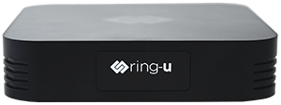

Hello Hub V2
Version 2 does not have a power switch or an internal backup battery, and power cycles/reboots like typical electronics. Unplug, pause, plug back in. The LED display will update as it boots up, showing network status, IP address, Internet Connection and more.

Hello Hub Micro Server
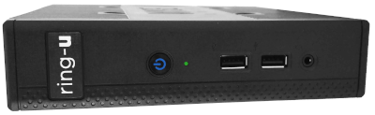
The Micro Server does have a power switch, but is configured in BIOS to automatically turn back on when power is restored. Note the blue lights on the power switch will show power on. Listen carefully and a voice will recite it's IP address and status at intervals.

Cloud Connector
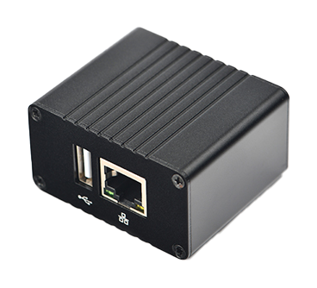
Cloud Connector does not have a power switch or an internal backup battery, and power cycles/reboots like typical electronics. Unplug, pause, plug back in. It's easiest to see indicator lights are on the ethernet jack.

Hello Hub V1
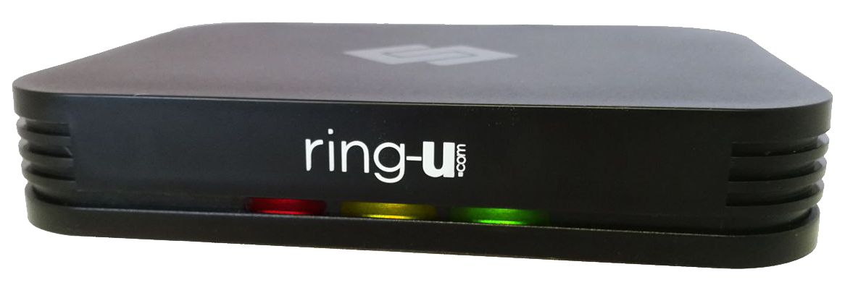

We've been asking HHv1 owners to remove the battery: [[battery|Battery Removal Instructions]]
The Hello Hub V1 has a built in backup battery good for more than 4+ hours without power. That's why you have to reboot it with the off and on switch. It was designed to be plugged into a common outlet or outlet strip with 110-120vac.
- Some UPS's and power strips turn off or go into “green/eco” mode when they don't sense their primary load, usually a computer. This makes the Hello Hub run on battery for a while, then die.
- Some UPS's are “spikey” when they cycle on/off, and that spike causes the Hello Hub's protection circuit to trip, which protects the Hello Hub. But it means the Hello Hub (and your phones) are offline.
Best way to reboot or power cycle a Hello Hub V1:
- Turn OFF the power switch on the back.
- Unplug the power cable.
- Make sure the lights are off.
- Turn ON the power switch (with it still unplugged).
- Plug the power cable back in.
- 2-3 minutes after this, we should have you back up and running.
- In 2-3 minutes you should have a working system.
If you would like your Hello Hub to boot fresh when everything else does after power outage, simply remove the battery from the battery box door on the bottom. If you are using a UPS or other power management solution, this might work better.

