Paging
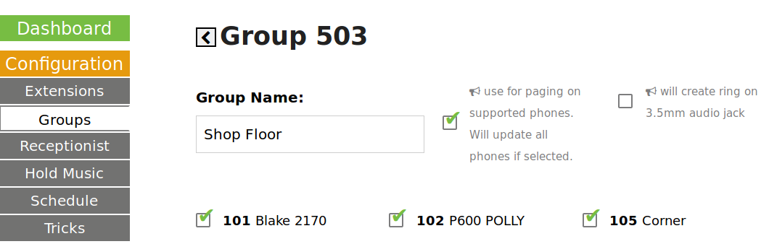
Grandstream, Most Cisco's, HTEK, Atcom… all listen for a multicast RTP audio broadcast on a port, per group.
For example: 224.0.0.1:503 is our group “503” - The Hello Hub (PBX) sends the broadcast audio and the phones receive it and play the audio.
We autoconfigure several brands and models of phones for this standard, and it works well, simply select the megaphone/paging icon in your group.
Dialing that group # (503 in this example) will turn all of the selected and supported phones in that group into a paging system.
Note that when a group with paging is updated, it may take several minutes to update all of the phones.

**ring-u** Does Not Support Paging on Polycom Phones
Polycom has their own ancient, proprietary paging protocol that is incompatible with the way everyone else does it now, but it does work well across severale venerable generations of Polycom phones.
Polycoms can be set to a Multicast IP address, and a port, but the format is different and includes a lot of things the rest of the world doesn't do. There are advantages to this, their paging can be set with a lot of options and behaviors (such as emergency paging that overrides everything and is much louder) but they are configured on each phone.
For instruction on setting up an Algo speaker, click here.

