SNOM PA1+ Manual Config
SNOM PA1+
SNOM Manual - pages 11 & 17 cover setup.
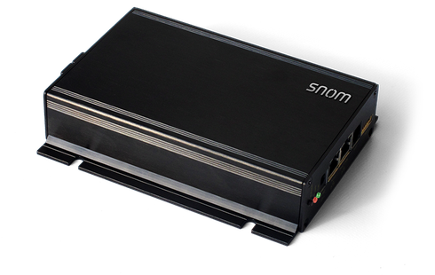

STEP 1
Create a manual extension through the Ring-U portal. You can create a manual extension by clicking: Configuration, then Extensions and at the bottom of the extensions page click the green Add Phone button:

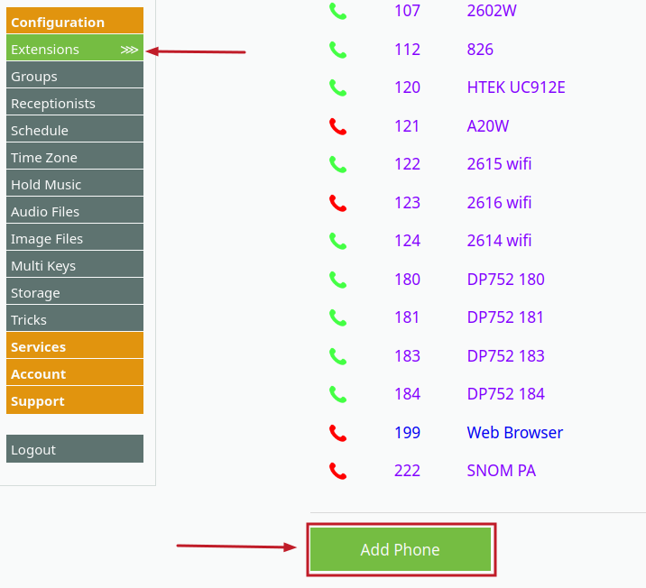

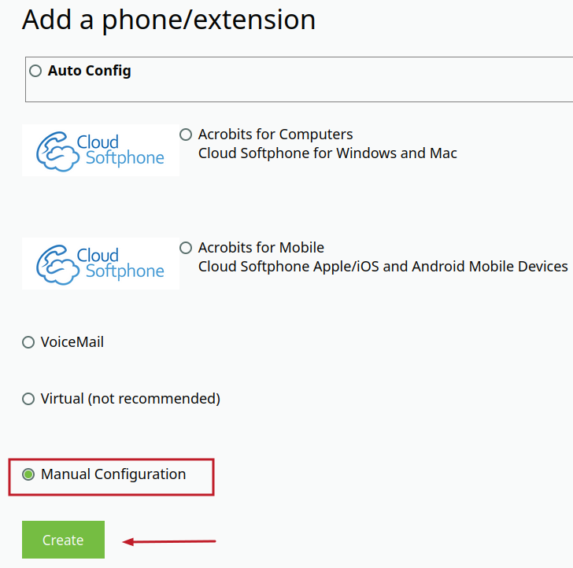

STEP 2
Give the extension a name and an extension number and click Save/Update.
IMPORTANT: The settings in the red boxes below are only used for this example. When you create your own extension manually, the information highlighted in the red box is UNIQUE to you.
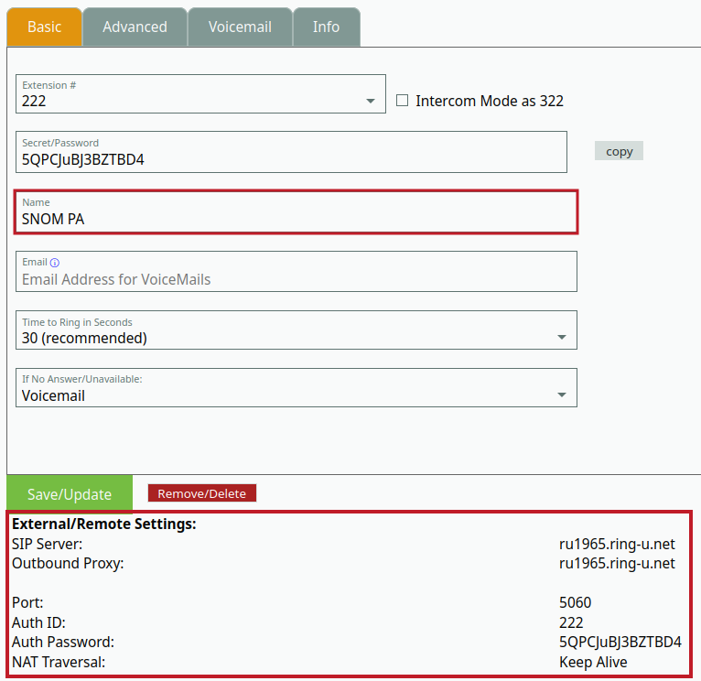

STEP 3
In another tab, log into the SNOM PA1+ by typing in its IP address into the address bar. You will need to be on a network that can communicate with the device.
Choose Identity 1 on the left side of the screen.
DO NOT USE THE SETTINGS LISTED IN THE EXAMPLE FROM STEP 2. Use the settings from the manual extension you just created. Each manual extension has its own unique settings.
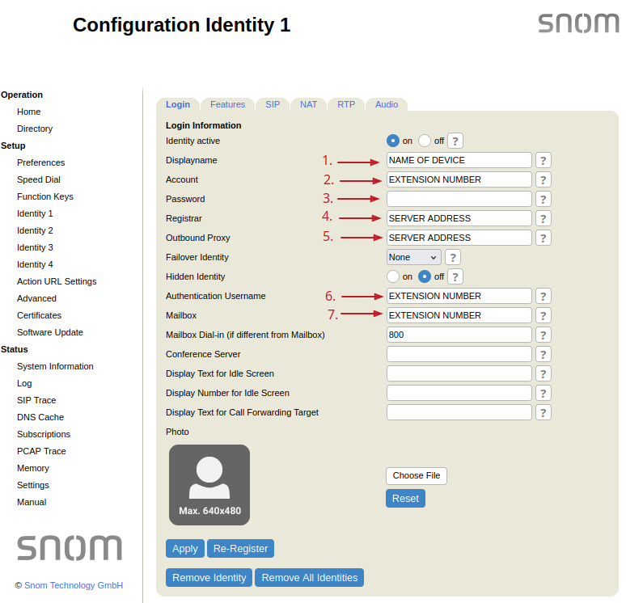
Box 1: This is the name you gave your extension. In our example, the extension was named SNOM PA, yours may be different.
Box 2, 6, and 7: Enter the extension number in this box. In the example, our extension was 222, yours may be different.
Box 3: Enter the Auth Password from your manual extension. We recommend copying and pasting this password into the box.
Box 4 and 5: Enter the SIP server information in this box. It is usually in the format of ruXXXX.ring-u.net, where XXXX is your Ring-U account number.

STEP 4
Click the NAT tab and set Keepalive interval to 15 and Number of Initial Keep-Alives on RTP port to 2.
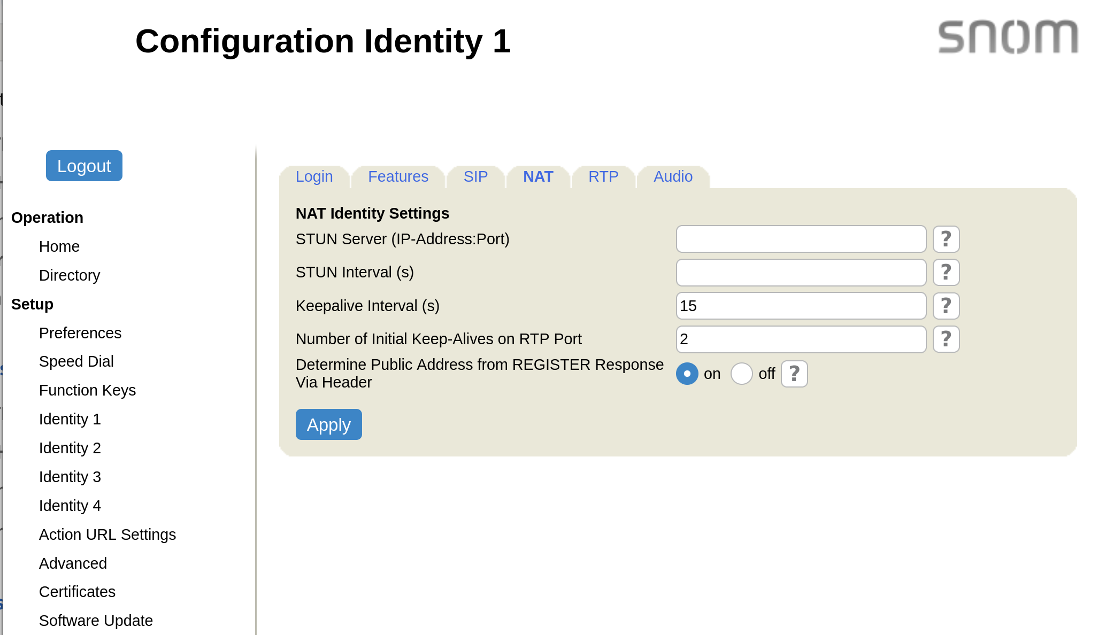
If you are configuring your SNOM for use as a ringer with a PA speaker, put this new manual extension in the group you want it to ring with and your setup is complete.
If you want to use a PA speaker as a standalone intercom, click on the manual extension again and check the box for Intercom Mode. Use the extension given to dial the speaker in intercom mode. If your extension is 150, intercom mode will enable as extension 250.
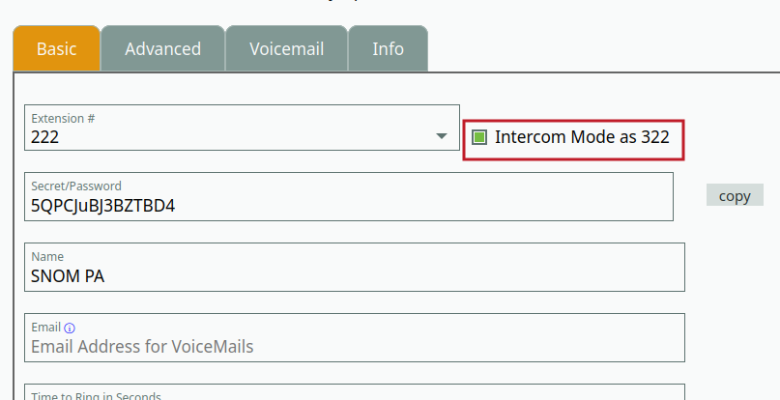

Multicast Paging Setup
These settings are only necessary if you intend to use multicast paging.

STEP 1
Click the Advanced option on the left side of the screen, pick the SIP/RTP tab and page down to the bottom:
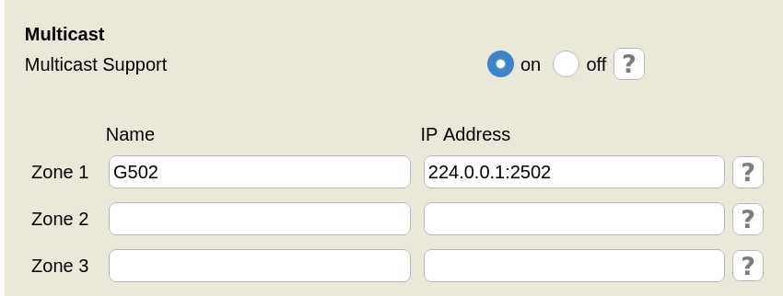

Enter a name for the paging group and its multicast address.
Note: The port number at the end of this multicast address corresponds to the group number you are configuring for paging. For example, this group is 502, so the port number is 2502, group 507 would be 2507. You can copy the full address directly by navigating in the portal to the group you are configuring and it will be listed in the top right where paging is enabled. See below:
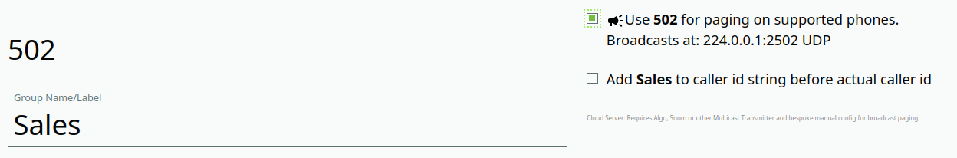

Click Identity 1 again on the left side of the screen, then click the SIP/RTP tab. Add the multicast address and port to the Multicast relay address box:
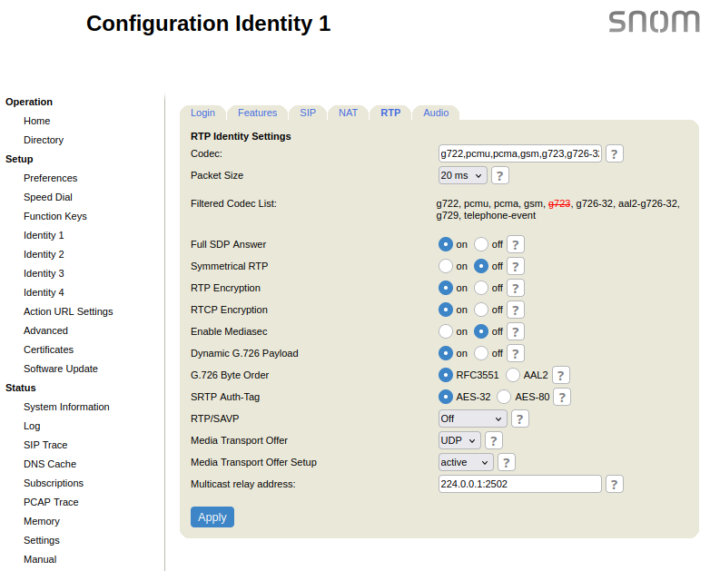
Click apply and the paging group should be ready to use by dialing the extension number. To configure another group, repeat this process with another manual extension and use Identity 2 through 4 to configure it.

