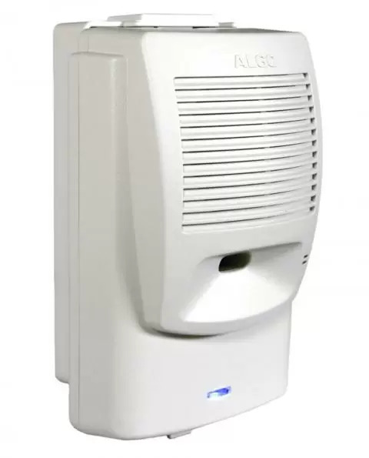

ALGO 8180 G2 Configuration Example
Algo 8180 G2 is a good example of a manually configured SIP device useful as a loud ringer or external paging device (loud speaker).
- Create a manual configured extension for use as a ringer, and as a paging extension. Two different extensions and uses.
- Access the Algo's web interface using HTTPS and the device IP address. Find the IP address on your DHCP server and/or follow the Algo instructions.
- Use the IP address of the Hello Hub as your SIP Server for both accounts.
- Use the extension # as the login ID, and copy the password from the Hello Hub Extension Page.
- Click 'Save' and test from other phones.

ring-u portal screen example
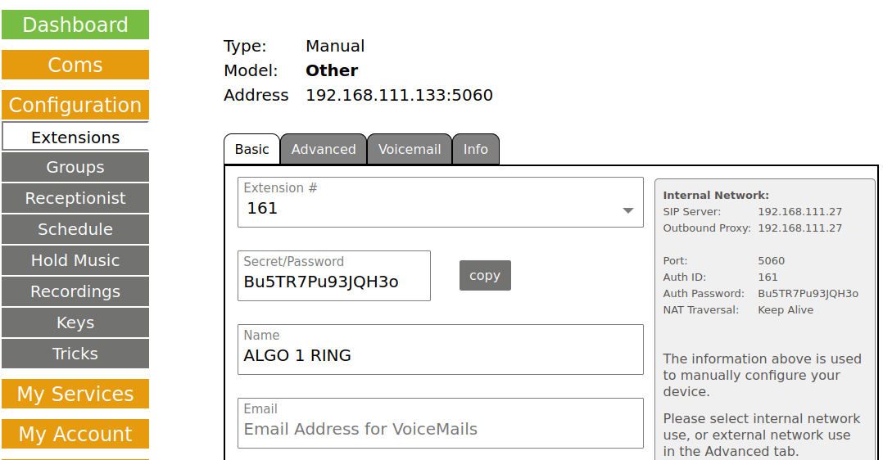

Matching ALGO 8180 G2 config screen example
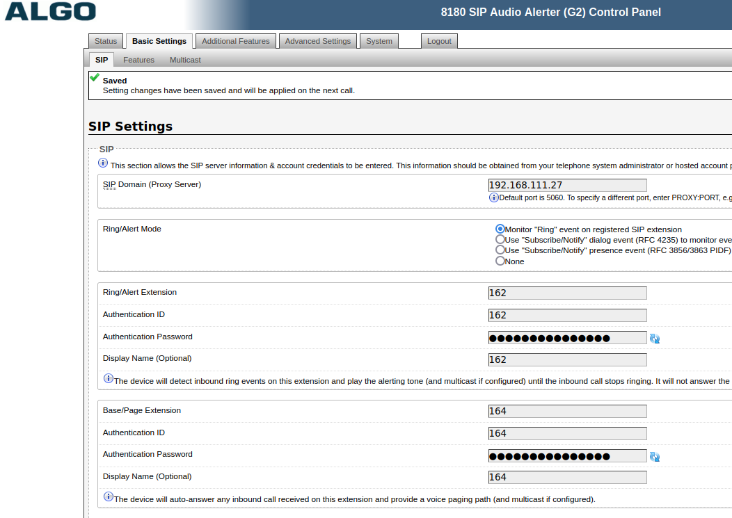

If a Hosted Hello Hub
Advanced Settings tab:
- Register/Subscribe Period(seconds): 120
- KeepAlive Method: Double CRLF
- KeepAlive Period(seconds): 10
- Server Redundancy: Disabled
This is overly aggressive, but should keep your firewall from timing out on these sessions. Our Hosted Hello Hub's have a long default timeout (hours), but good firewalls track UDP connections and drop them pretty quickly. We typically set automatically configured deskphones to 120 to 300 seconds for the same reason.

