Login

Admin Login
Admin rights are only available to the primary Customer/Admin.
Because this access grants full control, we absolutely discourage sharing access with anyone else.

User Mode
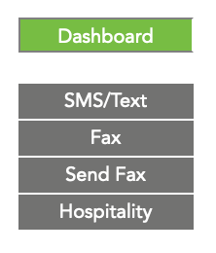
User Mode allows phone system user access to commonly used features by office staff, without access to the entire phone system. The feature set available currently provides access to Send and Receive both SMS/Text messages and Faxes. If you are a hospitality business and hospitality mode is available, you can also checkout room phones (reset and remove messages).
To Enable/Set
To enable “user” access to this mode, go to the individual's phone extension under Configuration→Extensions, choose the Advanced tab and enter a User Login Password.
- This password must be 8 or more characters. The password is saved as a hash and can not be displayed or recovered.
- You can enter in a new password, or use the word clear to remove the existing password.
- Your account number & extension are displayed in the help text to the right of the password entry screen.
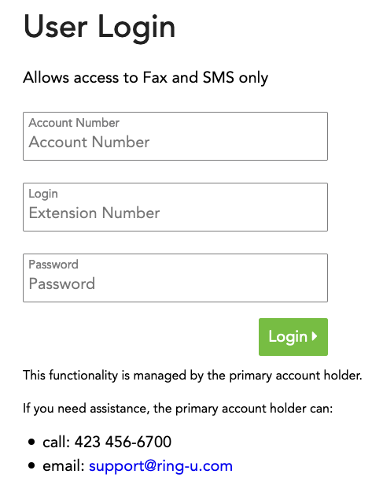
Suggested: To share a login among several staff members, use the system company mailbox extension #100.

User Login
From the main login login page is a link to the User Login.
Follow it to a screen depicted.
Use the account #, extension # and password set above.
If you need assistance logging in, contact your system administrator. If that's you, contact ring-u support at (423) 456-6700.

