Ideal Network Setup
We know all networks are different, but if you follow the basic structure laid out in the following two examples, you should be in good shape.
Regardless of network complexity, please do observe the following rules:
1. Keep your phone system network isolated from any security camera or streaming audio systems.
2. Do not double NAT. Only one device should be DHCP'ing on your phone system network.
3. Only use UNMANAGED switches. An unmanaged MANAGED switch will NOT work!
4. Do not use MESH routers or range extenders. Only use Access Points.

Basic Networks
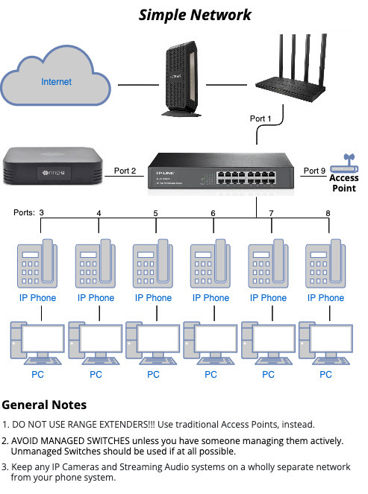

Complex Networks
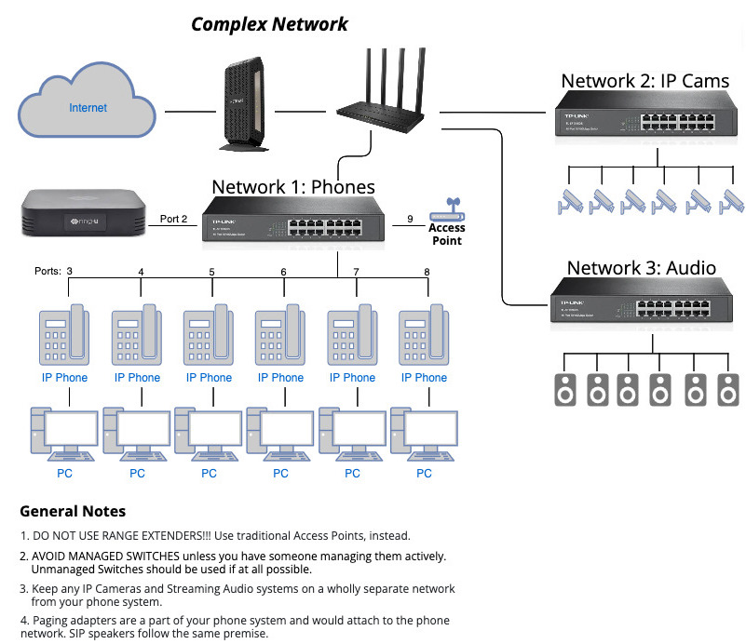
For a system requiring security on CPUs, please use separate LAN drops.
Phones should be on a relaxed security VLAN and an unmanaged switch if possible.
CPU's may then be on a separate switch/VLAN with whatever security is required.

