Hold Music
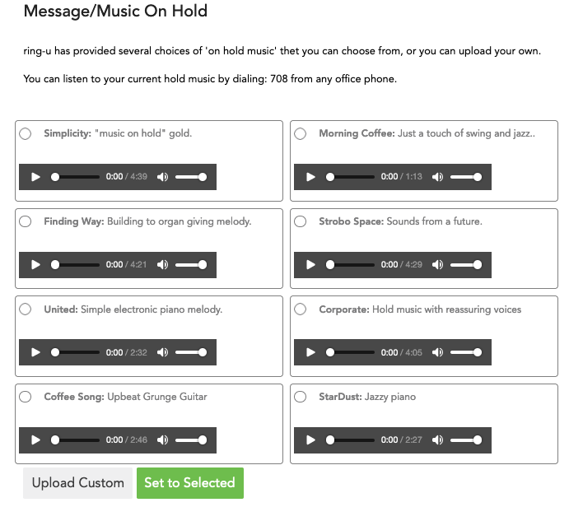
ring-u has provided several choices of 'on hold music' that you can choose from, or you can upload your own.
To listen to your current hold music from any phone in your ring-u system, dial 708.

Custom On Hold Recordings
The ring-u Hello Hub supports one custom “on hold” audio file that can be uploaded by the customer.
You can upload a stereo or mono .WAV for .MP3 file.
The system will convert it into an 8khz mono file, and when selected, will set your Hello Hub to play that file when a customer is “on hold” or “in queue.”
- Messages should be between 15 seconds and 2 minutes.
- Call queues time out at 45 seconds by default before going to the virtual operator to leave a message.
(sp)(sp)A good customer message should be less than 45 seconds.
- Music or background music behind a spoken message should be simple and should not distract from the voice.
- Be wary of niche musical genres. “Middle of the road” is a good place to be for most businesses.
- Do not use licensed or copyrighted music. ring-u is not liable for customer-uploaded audio files.

