Hello Hub v 1.0 Battery Removal
Ring-u will not be providing free replacements for battery related issues after October 31st 2021.
Ring-u would like you to check and see if your Hello Hub has a battery inside of it and remove it if so. We (ring-u) can not reliably determine if a battery is installed. We have received reports of a few batteries swelling and this is a concern.

History
We originally shipped Hello Hubs with the battery installed to provide power in case of outages. It seemed like a good idea at the time. We found over the last couple of years that the battery seldom helped in an outage and complicated troubleshooting certain issues. We stopped shipping hubs with batteries in them over a year ago, but there was stock at Amazon containing batteries until sometime this year.
Why are we asking you to remove the battery?: Because over time batteries degrade and can swell, or leak into the unit. We updated the firmware of all of the Hello Hubs in the field so that they would no longer charge the battery earlier this year, so there is no danger of overcharging.
Please do this as soon as possible. Call us if you have any questions at (423) 456-6700.

Removal Instructions
- Find your Hello Hub, Version 1
- Turn your Hello Hub OFF, by sliding the power switch on the rear of the Hello Hub towards the middle of the unit.
- Unplug the power cord.
- Turn the Hello Hub over, revealing the battery door.
- Unscrew the two small screws on the battery door.
- Remove the door.
- Remove the battery.
- Replace the door.
- Screw the door back in place.
- Turn the Hello Hub over.
- Turn the power switch on (towards the edge of the case)
- Plug in the power cable.
- Check that the lights on the front of the unit turn on.
- You should have a working phone system in about 3 minutes.
- Dispose of the battery per your local community guidelines. Many places offer drop offs for safe battery disposal, including most battery stores, auto parts stores and hardware stores.
Step by Step Pics:
Removing the battery door | 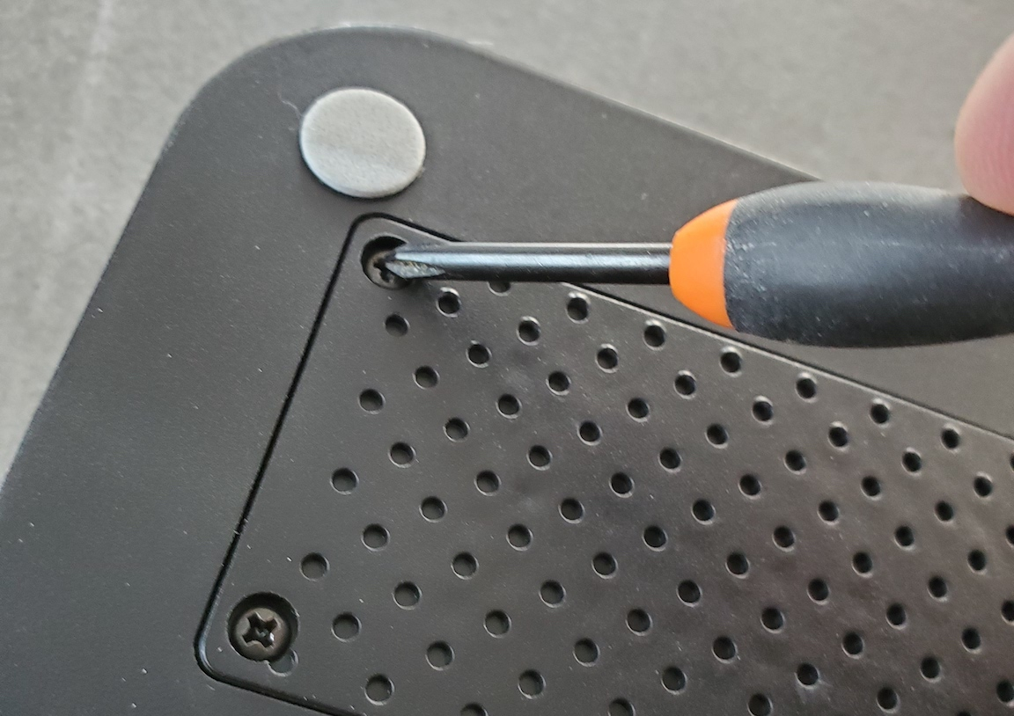
The battery, if installed | 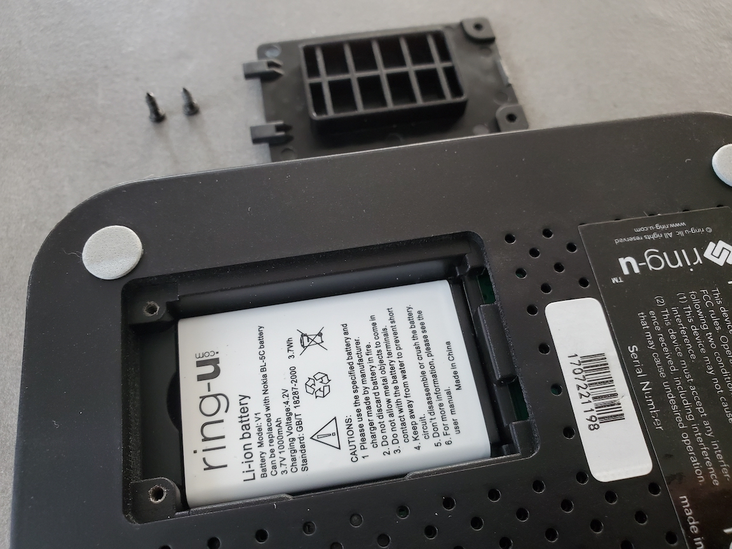
Remove the battery | 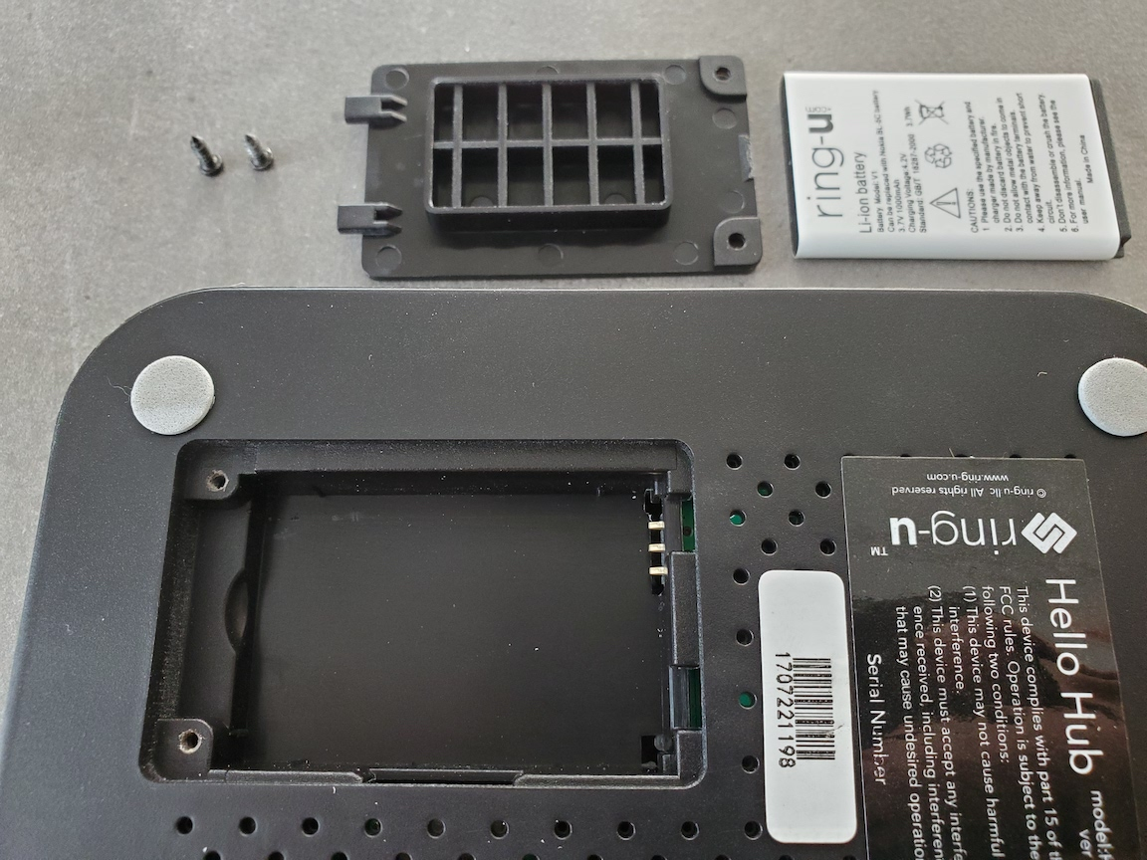
Replace the door | 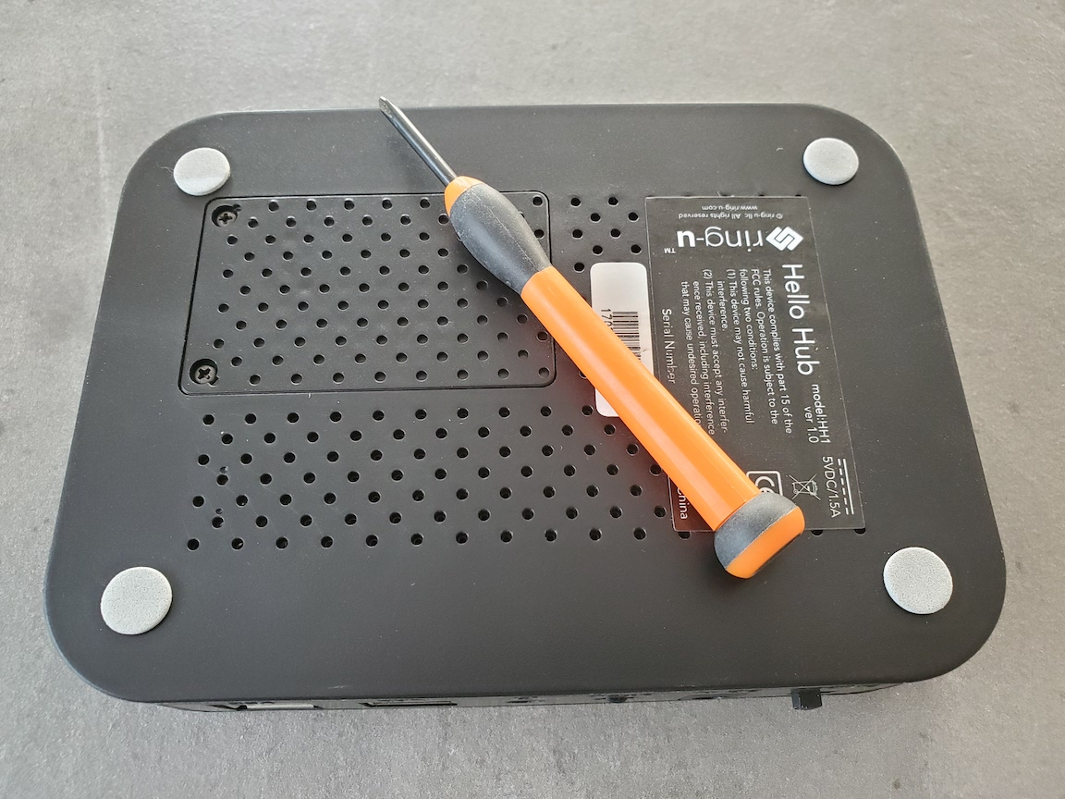
Also see our page on Reliability and Stability
Page created August 25th 2021, notices sent to all customers via email and as message on dashboard August 26th 2021

