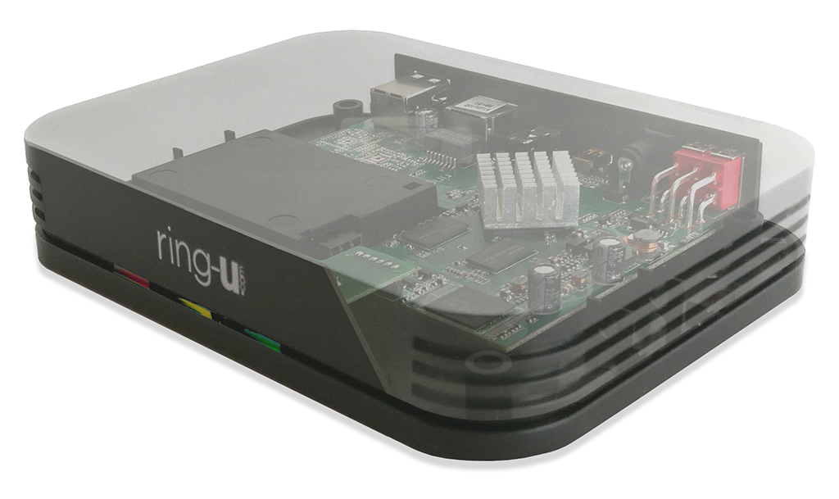

Hello Hub V1
The little black box that started it all.
Quad Core ARM.

Status Lights
The face of the Hello Hub (V1) houses 3 status lights.
From left to right when facing the ring-u logo:
1st Light turns red to indicate power is on.
2nd Light blinks yellow to indicate network communication.
3rd Light is the main status light.
(sp)(sp)It blinks blue when making attempts to contact the ring-u servers,
(sp)(sp)is solid green when it has a successful connection with ring-u,
(sp)(sp)and occasionally blinks purple to indicate that the battery monitoring service is working.
The 3rd Light can also indicate system errors.
(sp)(sp)Alternating Red and Yellow indicates that the Hello Hub has encountered an internal software error and needs to be powered off and on again.
(sp)(sp)An occasional red flash indicates that the Hello Hub failed to retrieve an update from the ring-u servers. It will try again automatically.
(sp)(sp)Cycling Colors (blue, green, red) indicates hub stuck in a boot loop. Hub cannot be contacted or helped (it's a goner).
(sp)(sp)Solid Red indicates the Hello Hub can not get past the firewall. A firewall reboot usually clears this error.

