Unpacking and Connecting
This page provides basic setup/installation instructions, including the list of the packaging contents, and also information for obtaining the best performance from your GRP261X series phone.

Equipment Packaging
Qty | Item
1 | Phone Main Case
1 | Handset
1 | Phone Stand
1 | Ethernet Cable
1 | Power Adapter
1 | Phone Cord
1 | Quick Installation Guide
1 | GPL License
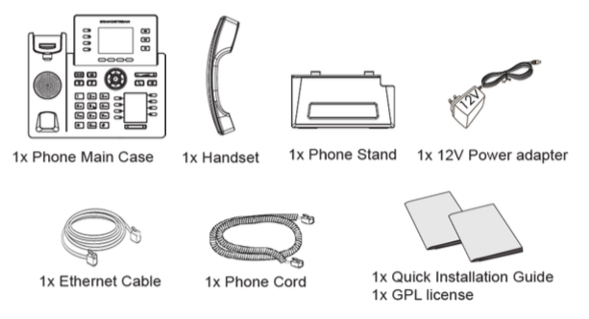GRP2614, GRP2615, GRP2616 Package Contents

Using the Phone Stand
To install the phone on the table with the phone stand, attach the phone stand to the bottom of the phone through the phone stand slot. (Upper half, bottom part).

Using the Slots for Wall Mounting
- Attach the wall mount spacers to the slot for wall mount spacers on the back of the phone.
- Attach the phone to the wall via the wall mount hole.
- Pull out the tab from the handset cradle (See figure below).
- Rotate the tab and plug it back into the slot with the extension up to hold the handset while the phone is mounted on the wall (See figure below).
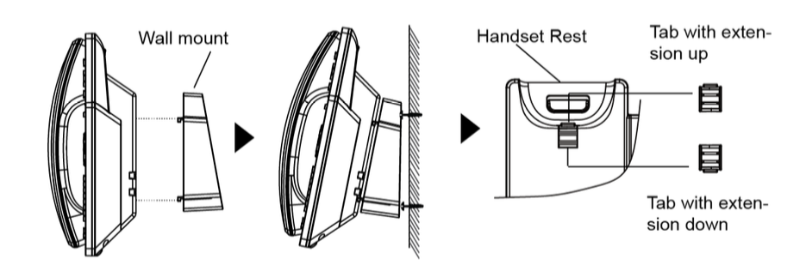Wall Mount Instructions

Connecting the GRP261X
To setup the GRP261X, follow the steps below:
- Connect the handset and main phone case with the phone cord.
- Connect the LAN port of the phone to the RJ-45 socket of a hub/switch or a router (LAN side of the router) using the Ethernet cable.
- Connect the PSU output plug to the power jack on the phone; plug the power adapter into an electrical outlet. If PoE switch is used in step 2, this step could be skipped.
- The LCD will display provisioning or firmware upgrade information. Before continuing, please wait for the date/time display to show up.
- Using the phone embedded web server or keypad configuration menu, you can further configure the phone using either a static IP or DHCP.


