Restore to Factory Default Settings - GRP2614, GRP2615, GRP2616
Warning: Restoring the Factory Default Settings will delete all configuration information on the phone. Any user-created settings will be lost. To reconfigure, go to Configuration > Extensions > Extension Number and re-save.
To restore factory settings using LCD menu:
Please follow the instructions below to reset the phone:
- 1. From the Home Screen, press the Round button between the 4 arrow buttons.
- 2. Navigate to System > Operations - Factory Reset and press Enter.
- 3. A warning window will pop out to make sure a reset is requested and confirmed.
- 4. Press the Yes soft key to confirm and the phone will reboot, or No soft key to cancel the reset.
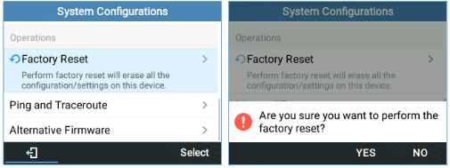Fig 89: Factory Reset Using LCD Menu

