Conference
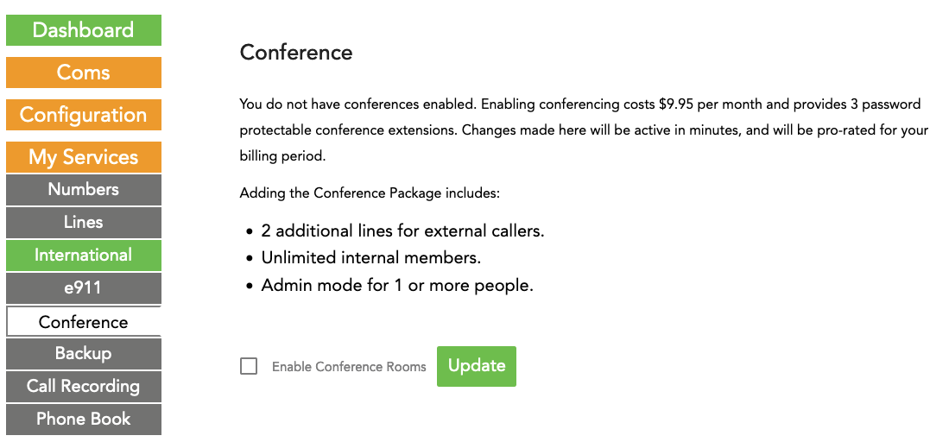
Enabling the Conference Feature
To use the ring-u Conference Center feature, enable it on your customer portal under My Services > Conference for $9.95 per month. You can cancel at any time. Keep in mind that internal extensions, including softphones on your system but outside of your office, do not count as users/lines. Only users dialing in from outside via your phone number count.
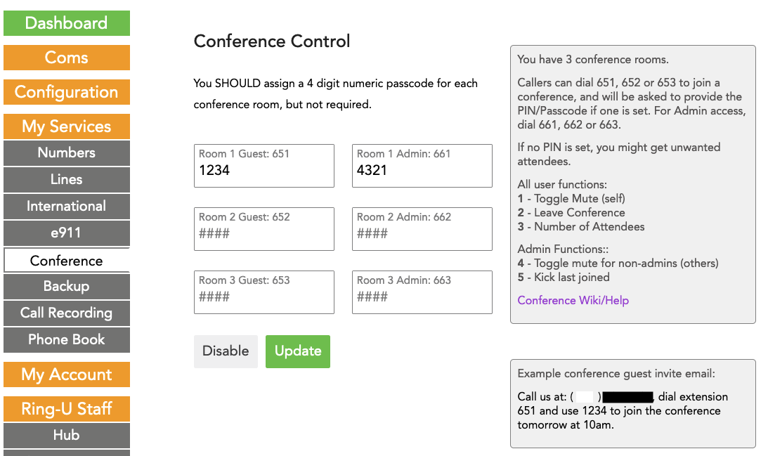
Configuration
Once enabled, you can configure your 3 conference rooms' access codes on the conference page.
While not required, we strongly recommend using a 4 digit access pin to help keep your conference secure.
Accessing the Conference
Callers enter a conference room via an IVR/Receptionist menu item or by direct dialing the conference room.
A busy office may choose to have conference rooms available from their auto-attendant menu, but a receptionist can easily transfer callers to conference rooms by dialing 651, 652, or 653.
Callers will be asked to enter their pin and say their name to announce their entry into the room.

Features
User/Guest Functions While in a conference, any user may use the following functions from their keypad:
1 - Mute on/off.
2 - Leave Conference. Or you can just hang up.
3 - Participant Count. Announces how many other people are in the room.
Admin Functions If you access the system as an Admin using 661, 662 or 663 and the admin PIN code for the room, you can also:
4 - MUTE all non-admin's on/off. If you have more than one admin, they will not be muted.
5 - Eject the last person that joined the conference from the room.
Sample Usage The Acme Corporation is hosting a training session. They have made Conference Room 1 (651/661) menu option 6 on their receptionist menu.
The presenters ask 5 people to call in at 10am and choose option 6, and use PIN 1234.
The presenters dial 661 to enter the room as Admins a few minutes early with their PIN of 9234.
After a little chit chat, the admins mute the room by pressing 4, and start their presentation.
10 minutes later is Q&A time, so they press 4 to unmute everyone.
Bob (not an admin), was the last person to join the meeting but the first to ask a question, and won't shut up after asking an off-topic, conspiracy-laden question.
An admin dials 5 to kick him from the conference to get the conference back on track.
They answer questions, talk about the news and say goodbye.
Everyone hangs up, but not one to be silenced, Bob later sends an epic email with the rest of his ramble.
If call recording was also enabled, the entire conference was recorded. Even Bob.
No actual Bob was injured in this example. Any resemblance to a real Bob is coincidental.

