Polycom Dial Map Woes
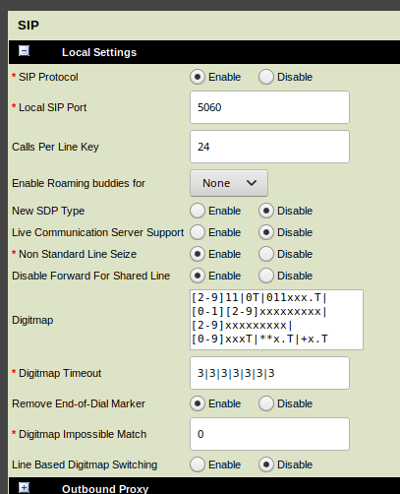
Many Polycom phones can not dial internal 3 digit numbers that start with 10 or 11 due their Dial Map. It's the rules that say what you can and can not dial. You can change this via the Web Interface under Settings→SIP. It should look like the image on the right.
Original default test:
[2-9]11|0T|011xxx.T|[0-1][2-9]xxxxxxxxx|[2-9]xxxxxxxxx|[2-9]xxxT|**x.T|+x.T
New version, 1 character different:
[2-9]11|0T|011xxx.T|[0-1][2-9]xxxxxxxxx|[2-9]xxxxxxxxx|[0-9]xxxT|**x.T|+x.T

