OPENVPN on Grandstream Phones
Bluntly, this is rocket science. We don't do this unless under duress. Example: your country that a remote office is blocking all non-encrypted traffic and we like you enough to setup OpenVPN as a server on a hosted/cloud Hello Hub. We'll create the OpenVPN server and configure it. This is a low to moderate security VPN. It's primary purpose is to punch through firewall/traffic restrictions, not to protect you from the NSA, KGB or other nation state level actors.

Step 1 - OpenVPN
The client/user will need to take the three files we provide and login in to their phones using a web browser. We can not provide or configure them via our automated systems.
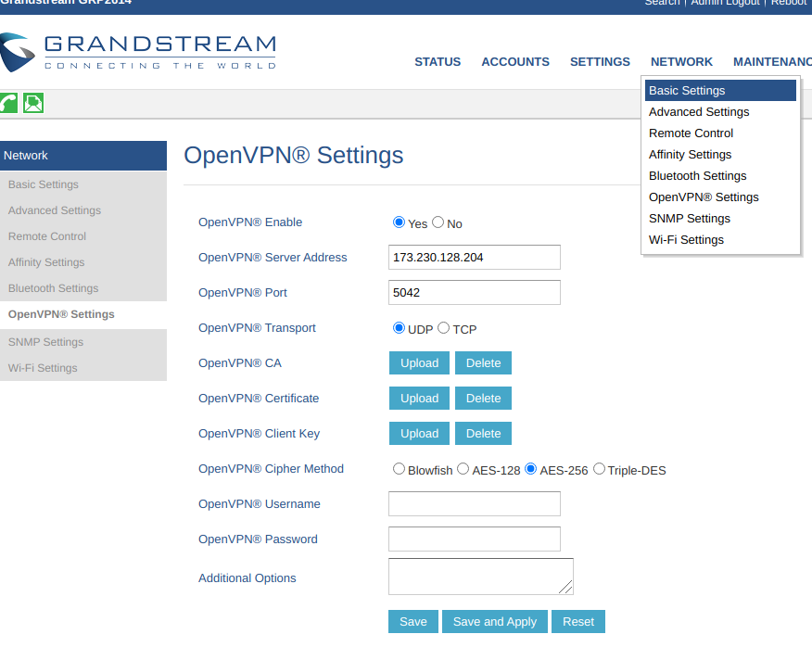
We'll send you the three files.
ca.crt is uploaded to “OpenVPN CA”
phone01.crt is uploaded to “OpenVPN Certificate”
phone01.key is uploaded to “OpenVPN Client Key”
The server address is the ipV4 address of your cloud/hosted Hello Hub. The IP in the image is an example.
The port will probably 5042 - an atypical port for either VPN's or VoIP/SIP.
The Cipher method is AES-256
No username or password is required.
Click Save and Apply reboot and pray.

Step 2 - Account Mods
Under Accounts→Account 1 Set the SIP Server IP Address and Outbound Proxy IP address to 10.42.42.1 This is both the Hello Hub and VPN Server Address.

Disclaimer
Depending on too many factors to explain, this may still not work. But so far is getting phones working behind very restrictive nation state firewalls to Hosted/Cloud Hello Hubs

