Backup & Priority Replacement
Effective January 1, 2023, Backup will be included with all plans by default, but overnight shipping will only be offered if purchased at the time of replacement.

March 1, 2022 through December 31, 2022
For plans created March 1, 2022 through December 31, 2022, Backup is included with all plans by default, but overnight shipping is no longer included, unless purchased at time of replacement.

Legacy Accounts (opened prior to March 1, 2022)
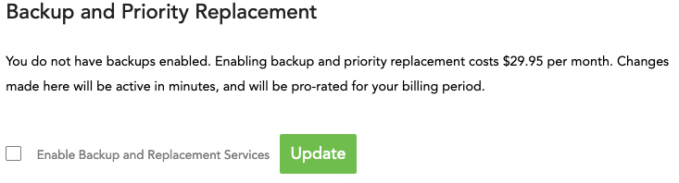
Backups Disabled
ring-u systems default to Backup being disabled.
Enabling backup and priority replacement costs $29.95 per month.
Enabling the service takes effect in minutes, and will be pro-rated for your billing period.
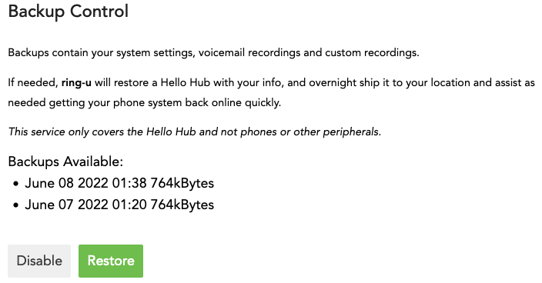
Backups Enabled
Once enabled, backups are listed in this screen.
Should your system fail, ring-u will restore a Hello Hub with your most recent backup, overnight ship it to your location, and assist as needed to get your phone system back online quickly.

