Mobile App End User License Agreement Terms and Conditions
Ring-U LLC, a Chattanooga Tennessee USA based Telecom Services company has licensed Acrobits Cloud Softphone, a provider of “white label” VoIP Softphones for telecom companies to work with their systems.
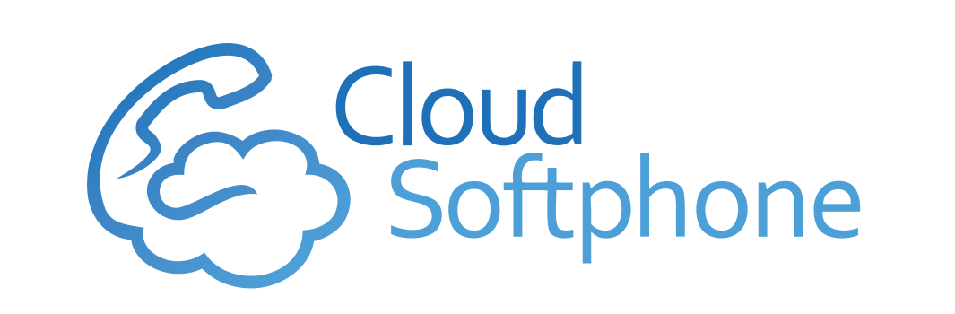
The Cloud Softphone Application, once installed on a mobile device and configured by QR Code or Login and Password is tied to a customers Ring-U LLC phone system and a specific extension, automatically. The user most have an active Ring-U LLC phone system for it to work, and is configured via https://portal.ring-u.com
Ring-U LLC nor AcroBits is responsible for the use and suitability of this application but will make a best effort in supporting it. Our experience with it has been excellent in most situations.
Most of the variables are under control of the phone operating system (iOS/Android) and telecom provider (Verizon/Sprint/AT&T/T-Mobile, etc..) as well as options configured on the mobile device by the end user.

