Acrobits Softphone Do Not Disturb Scheduler
Acrobits features a Do Not Disturb Scheduler that allows you to set a daily schedule for when your phone goes into Do Not Disturb Mode.
Suggested uses for this would be:
- scheduling a time each morning when you are dedicated to a recurring meeting or task, or
- when you leave work each day.
To set a schedule, open your softphone app, tap the gear icon, go to Preferences > Do Not Disturb > tap the + symbol to add a schedule. The app supports multiple schedules, but before getting too complicated, please make sure there are no conflicting overlaps.
The schedule screen looks a bit different between Apple and Android devices, but generally, a check mark or grey highlight indicates a day the schedule will apply to. The schedule will apply Do Not Disturb status to the checked days and times listed in your schedule. Enable must be marked to make the schedule active. Press ADD to save the schedule.
Screenshots

Android
In this example, Do Not Disturb is enabled 7 days a week from 9:30am to 11:55am for all callers.
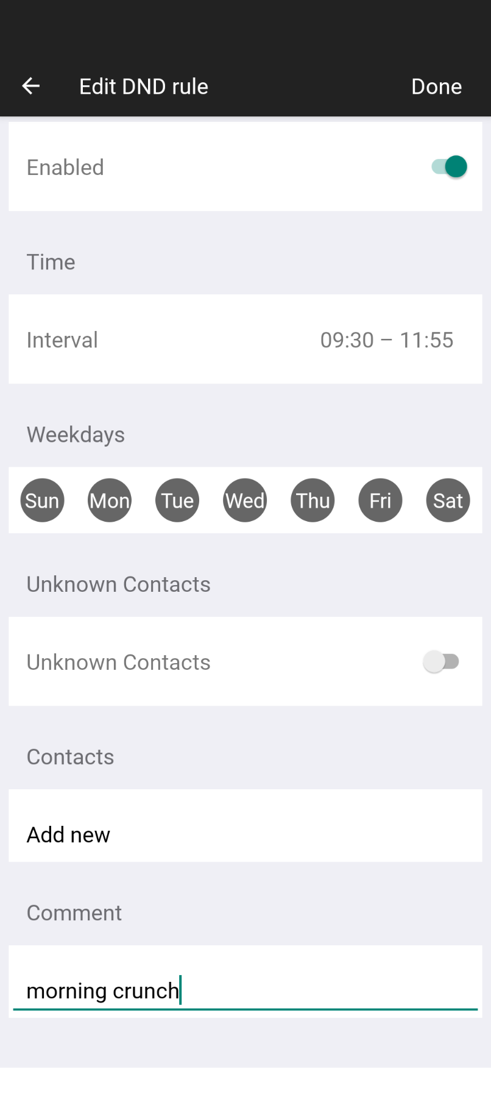

Apple
In this example, Do Not Disturb is enabled 7 days a week from 8:00am to 4:00pm for all callers. Sliders or suggested time presets may be used to set the time range for Do Not Disturb. Tap on the schedule listing after it's been saved to edit it.


