Acrobits Cloud Softohone for Computers

Microsoft Windows Computers:
Windows .Appx Installer
Windows .EXE Installer

Apple Mac Computers:
Apple Chip Mac Installer - newer systems
Intel Chip Mac Installer - older systems

Instructions
Download and install the version above for your computer.
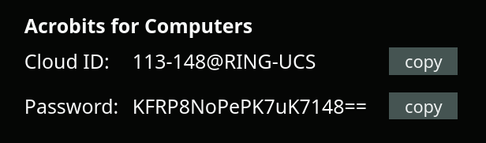
When ran, it will ask you for a “Cloud Id” and “Password”, these are available from your Ring-U dashboard when you create a Acrobits Cloud Softphone for Computers. The example provided is NOT valid.

