Acrobits Cloud Softphone
Ring-U has licensed the Acrobits Cloud Softphone, a powerful “white label” popular application available in the iOS and Android App Stores. Note that the iOS variant shows Alien Licensing as the vendor, this is correct.

Acrobits Cloud Softphone on Ring-U Features
- Auto Configuration via QR Code or a simple form.
- Push Notifications. Saves battery life, works better on mobile data.
- TLS/SSIP connections: Works better punching through various firewalls/Wifi/ISP's and provides a reasonable level of encryption/security.
- Contacts Integration with your Ring-U phone system.
Limited to Cloud/Virtual subscribers only.

Installation and Configuration
Step 1: Download and install the Acrobits Cloud Softphone application on your mobile device (Phone or Tablet).
App Store Image
Android | iOS
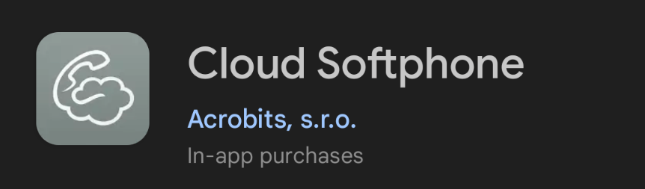 | 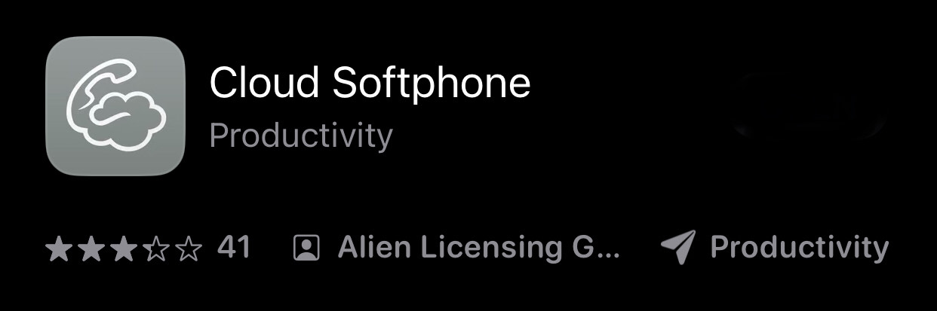
https://apps.apple.com/us/app/cloud-softphone/id567475545
https://play.google.com/store/apps/details?id=cz.acrobits.softphone.cloudphone&pli=1
Step 2: Run the application, it will present a login/configuration screen:
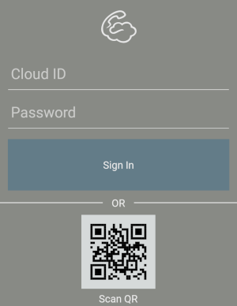
Step 3: Use the Scan QR button and scan the QR code on the phone extension configuration page you created using “Add an Extension.” Remember to make changes to the extension's “Basic” tab info and save it prior to scanning it into the app.
Alternative configuration: You can enter the Cloud ID and Password from that screen into the form. Useful for configuring a remote employee phone. You can also send them the QR code. Unlike Zoiper, these QR codes are “sticky” and usable until that phones extension and password has been changed.
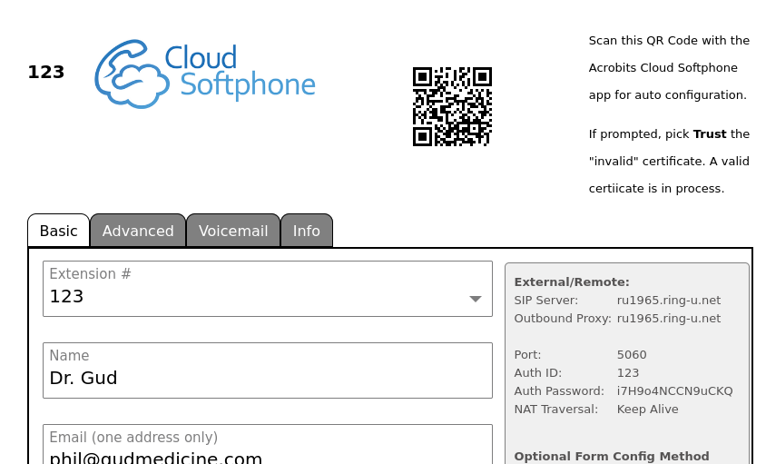
Step 4: Wait until the “ring-u” button at the top left of the dialer screen turns green, then place an initial test call. We suggest “000”. The first time the phone makes a call, it may take a few seconds to complete it's configuration.
Step 5: Select a ring tone. Initial configuration set to “Default” which may not be valid on some phones.

Digression
We were promotng GrandStream Wave, Zoiper and Linphone as softphone apps for our customers. Wave has been pulled from the app stores. Zoiper has had a rash of technical issues and outages. When we started ring-u many years ago, we met the Acrobits crew at a conference. They were not cheap and out of our range at the time. When Wave and Zoiper started to have issues, we reached out to Acrobits. The same person we worked with many years ago was still there, and their systems have improved while their price and value has gotten better. Acrobits Cloud Softphone is a solid application that configures itself to our systems and users needs well. In the near future we intend to have a completely ring-u branded version of it for our customers.

